Pratyusha Thundena

Laboratory 1

FA2017 CS 103L-F4 Introduction to Computation Lab

September 14, 2017

Source Code

First Program:

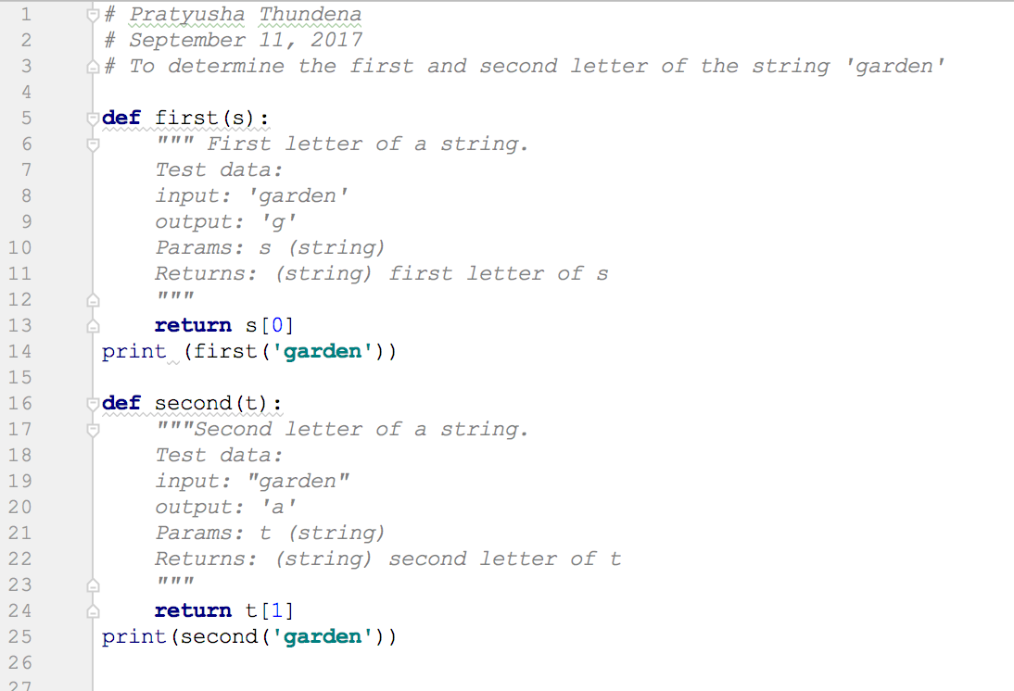

Second Program:

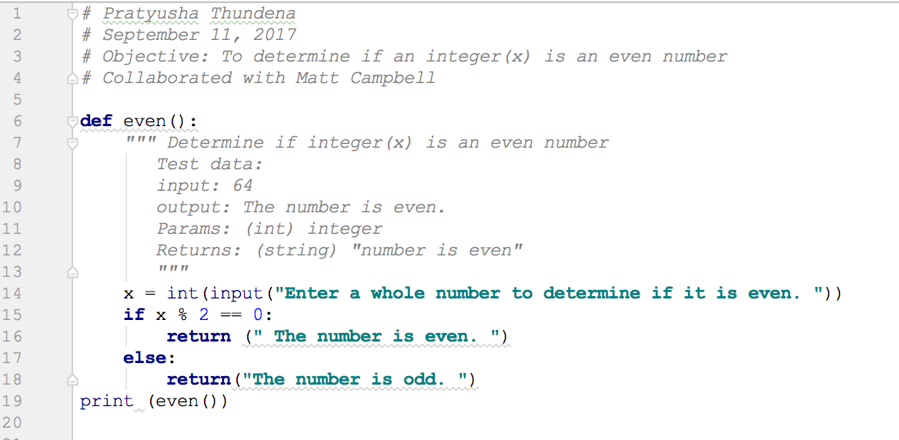

Third Program:

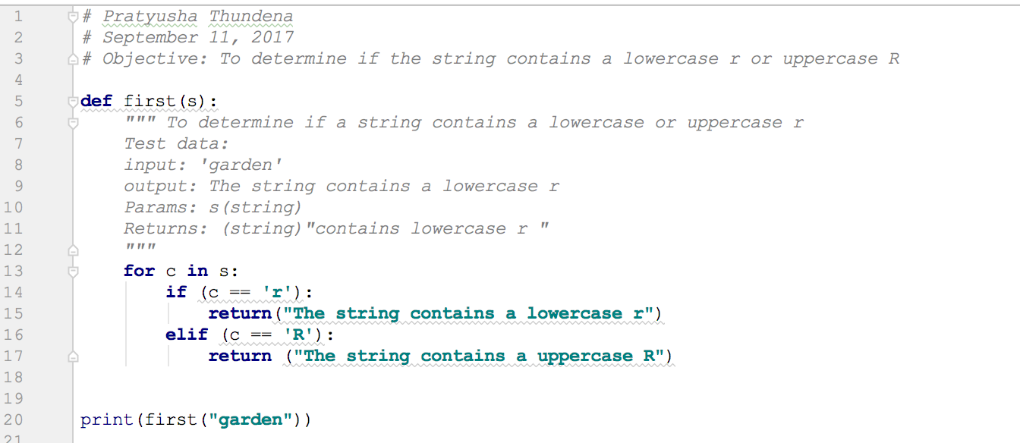

Fourth Program:

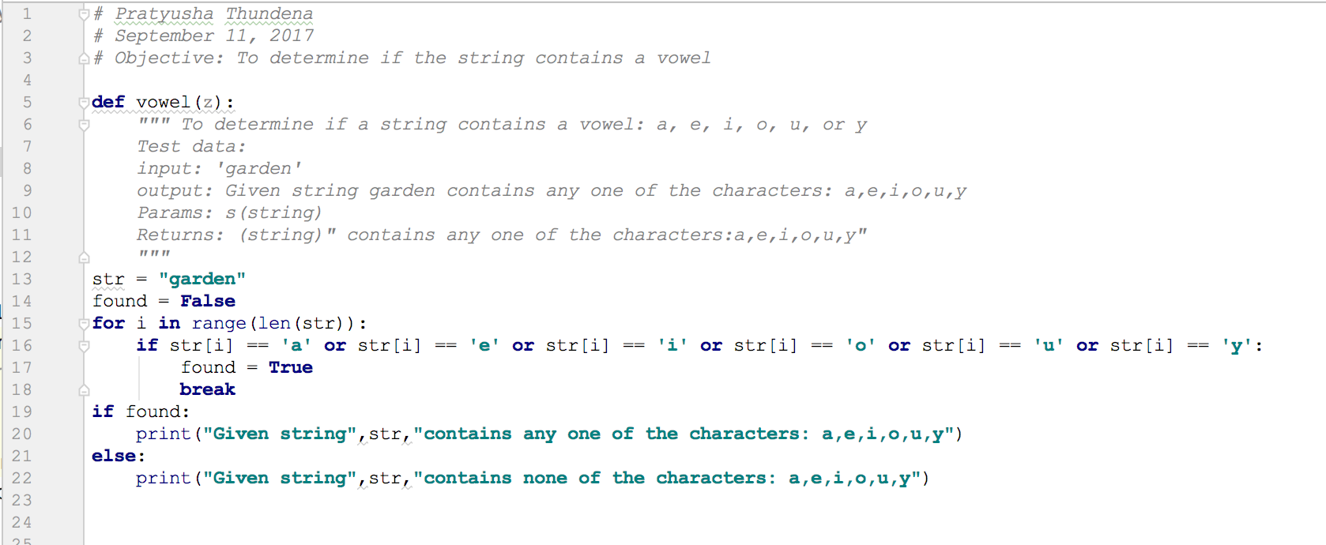

Fifth Program:

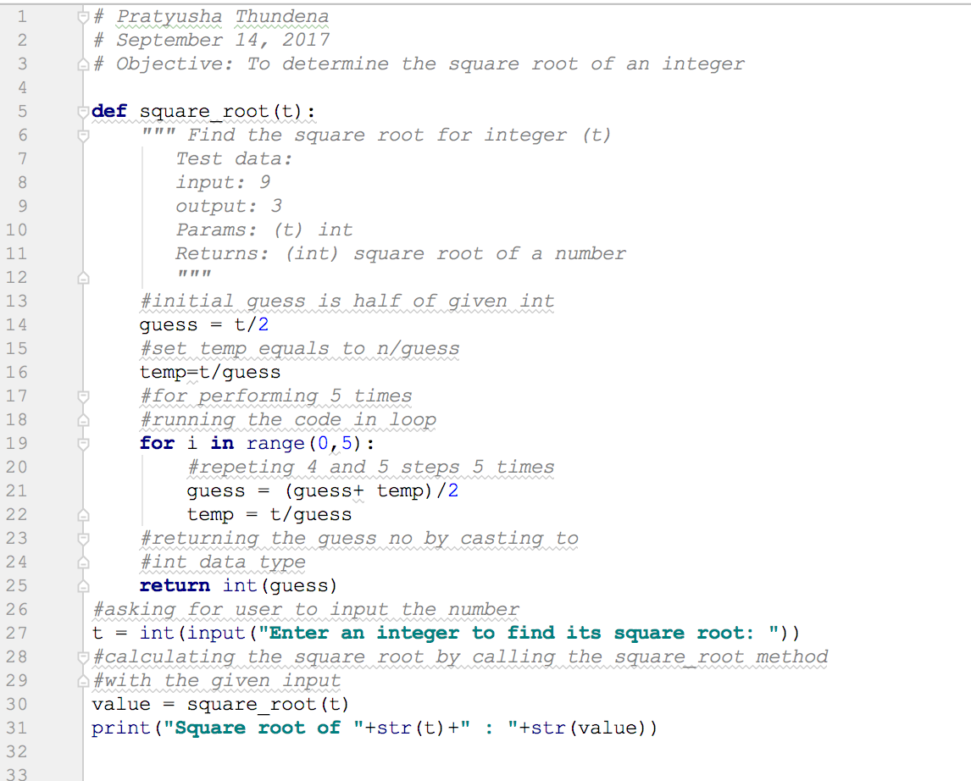

Demonstration to TA

Source codes demonstrated on 9/11/2017 at approximately 2:05 pm (CST) to BreAunna.

Program Results

First Program Output:



Second Program Output:



Third Program Output:



Fourth Program Output:



Fifth Program Output:



Conclusion and Results

This lab taught students that writing code is one of the last steps of programming. One must

consider the dialogue, in which, one understands the type of program that needs to be created.

Then the programmer should write down any specifications that the program should contain.

Afterwards, one must define the abstractions in order to help keep track of values and parameters.

All of the previously mentioned steps are part of the Methodology for Algorithmic Problem

Solving (MAPS), and these steps occur before writing, testing, and verifying the code. I had

difficulty with the fourth program, in which, I had to create a code with a for loop in order to show

that the string ‘garden’ contained a vowel. However, I eventually figured out how to make the

code work. All five programs taught me that I need to continue to practice coding; specifically,

doing loops to solve a problem. On the bright side, I realized that there is more than one way to

solve a particular coding problem.